isco Router Password Recovery

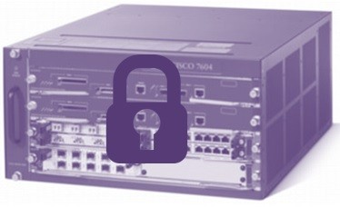

How to Password Recovery on Cisco Routers?

There are several reasons to recover a router’s **enable password**. For example you can forget the password or somebody might give a password that you don’t know. So, to reach your router’s or switch’s command line interface, you should recover this password. In this lesson, we will focus on **Cisco Password Recovery**.

During your access and **Cisco Password Recovery**, it is important that recovering the password without loosing any configuration. To recover a Cisco router’s, switch’s **enable password**, do the followings:

**1-)** FOr **Cisco Password Recovery**, firstly we will prevent the IOS load at the beginning. For this during startup use **CTRL+BREAK (CTRL+C)**. By doing this, we will enter the ***rommon*mode***. By the way****rommon mode*** is a limited operating system on router.

**2-)** In Rommon mode we will change the [**configuration-register**](https://ipcisco.com/lesson/configuration-register/). To do this, write **“o/r 0×2142”** command. By entering this command we prevent the router to load the configuration on NVRAM.

**3-)** Here, shutdown the router. This time, because of the fact that our configuration wasn’t been loaded, IOS will ask us if we think to buld a new configuration.Our answer will be No. After that the default command line **router>** will appear.

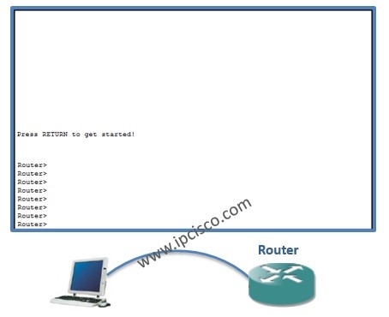

Table of Contents

[](https://ipcisco.com/lesson/common-cisco-router-configuration-on-packet-tracer/)

* [Basic Cisco Router Configuration](https://ipcisco.com/lesson/common-cisco-router-configuration-on-packet-tracer/#Basic_Cisco_Router_Configuration)
  + [Basic Cisco Router Configuration: How to Start to Configure a Router?](https://ipcisco.com/lesson/common-cisco-router-configuration-on-packet-tracer/#Basic_Cisco_Router_Configuration_How_to_Start_to_Configure_a_Router)
  + [How to Configure a Router’s Hostname](https://ipcisco.com/lesson/common-cisco-router-configuration-on-packet-tracer/#How_to_Configure_a_Routers_Hostname)
  + [How to Give a Password to a Router?](https://ipcisco.com/lesson/common-cisco-router-configuration-on-packet-tracer/#How_to_Give_a_Password_to_a_Router)
  + [How to Configure Console Connection Options?](https://ipcisco.com/lesson/common-cisco-router-configuration-on-packet-tracer/#How_to_Configure_Console_Connection_Options)
  + [How to Configure Your Telnet Connection Options?](https://ipcisco.com/lesson/common-cisco-router-configuration-on-packet-tracer/#How_to_Configure_Your_Telnet_Connection_Options)
  + [How to Configure an Interface of Router?](https://ipcisco.com/lesson/common-cisco-router-configuration-on-packet-tracer/#How_to_Configure_an_Interface_of_Router)
  + [Let’s Write a Console Message Like the Software Developers “Hello World” :)](https://ipcisco.com/lesson/common-cisco-router-configuration-on-packet-tracer/#Lets_Write_a_Console_Message_Like_the_Software_Developers_Hello_World)
  + [What About Saving The Configuration?](https://ipcisco.com/lesson/common-cisco-router-configuration-on-packet-tracer/#What_About_Saving_The_Configuration)
  + [Verification of Basic Cisco Router Configuration](https://ipcisco.com/lesson/common-cisco-router-configuration-on-packet-tracer/#Verification_of_Basic_Cisco_Router_Configuration)

## Basic Cisco Router Configuration

In this **Basic Cisco Router Configuration**lesson, we will see **how to configure a Cisco router** basically with the help of **Packet Tracer**. This [**CCNA lesson**](https://ipcisco.com/course/ccna-certification/) will be an entrance to routers for a Cisco router newbie. Here, we will see Basic Cisco Router Configuration.

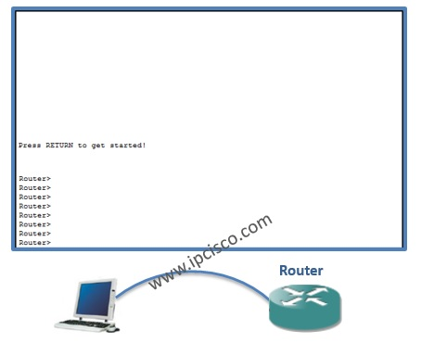

You can **DOWNLOAD**the **Packet Tracer** example with **.pkt** format [**here**.](https://ipcisco.com/wp-content/uploads/PacketTracer/commonconfiguration.rar)

### **Basic Cisco Router Configuration: How to Start to Configure a Router?**

This is the fisrt question of a Cisco router newbie, a new network engineer :) Do not worry it is vey basic. To configure a Cisco router, first of all youneed to enter the **“enable mode”**. Normall you are under user mode, you can run only show commands. To enter enable mode use the below command:

**Router>enable**

After this command you are in enable mode. But to make configuration, you need to enter also teh below command under enable mode:

**Router#configure terminal  
Enter configuration commands, one per line. End with CNTL/Z.  
Router(config)#**

Now you can do any configuration on the Cisco router. After a while, you will gain **Cisco hands on experience** and speed. At this time you will write “**e**n”, instead of enable, “**conf ter**” instead of configure terminal etc…

### **How to Configure a Router’s Hostname**

To configure the **hostname**of the router, use the below command. Here, hostname is the name of your router.

**Router(config)#hostname MyRouter  
MyRouter(config)#**

As you can see, the name of the router has changed as MyRouter.

### **How to Give a Password to a Router?**

To give a password to your router, you can use the **“Enable Password”** and **“Enable Secret Password”**. **Enable Password** stores your password as a clear text. If you want to encryp it you need to use **service password-encryption** command. **Enable Secret Password** stores your password in **MD5**encryption. And **“Enable Secret Password”** is more secure. You can check the seem of enable secret in configuration file below.

**MyRouter(config)#enable secret 1234567  
MyRouter(config)#service password-encryption**

You can view the encrypted password with “**show running-config**” command.

**MyRouter#show running config**

**…  
enable secret 5 $1$mERr$iHGIpzTedTCk9bQ93Wry30**

**…**

### **How to Configure Console Connection Options?**

You can configure your console connection. The console password, the history size can be configured. To do this we will use the below commands in thiz **Basic Cisco Router Configuration** lesson.

**MyRouter(config)#line console 0  
MyRouter(config-line)#password cisco123  
MyRouter(config-line)#login  
MyRouter(config-line)#history size ?  
<0-256> Size of history buffer  
MyRouter(config-line)#history size 10**

Beside these the logging syncronization of console can be configured here. Many new engineers complaintive about the logging synronization of the console. While they are writing someting on the router, it sometimes print something on the secreen and divides your writings. I do not affect the command but it affect your seem. To avoid this, use **“logging synchronous”** command.

**MyRouter(config-line)#logging synchronous**

You can also **DOWNLOAD**all the **Packet Tracer** examples with **.pkt** format in [**Packet Tracer Labs**](https://ipcisco.com/cisco-packet-tracer-configuration-examples/) section.

A second more complaint comes about the time out of the session. After a certain of time without a user input, your router time-out. To avoid this use **“exec-timeout”** command.

**MyRouter(config-line)#exec-timeout ?  
<0-35791> Timeout in minutes  
MyRouter(config-line)#exec-timeout 0 ?  
<0-2147483> Timeout in seconds**

**MyRouter(config-line)#exec-timeout 0 0**

### **How to Configure Your Telnet Connection Options?**

You can use the same commands used in console connection options under also telnet connection. There are 0 to 15 telnet connections.

**MyRouter(config)#line vty 0 15  
MyRouter(config-line)#password cisco123  
MyRouter(config-line)#login**

### **How to Configure an Interface of Router?**

To configure an interface, firsty you need to go to that interface configuration mode. And then, under this interface, add the ip address with its mask. Do not forget to write “no shutdown”. This opens the interface.

**MyRouter(config)#interface GigabitEthernet 0/0  
MyRouter(config-if)#ip address 10.0.0.1 255.255.255.0  
MyRouter(config-if)#no shutdown**

**MyRouter(config-if)#  
%LINK-5-CHANGED: Interface GigabitEthernet0/0, changed state to up**

### **Let’s Write a Console Message Like the Software Developers “Hello World” :)**

“**Banner Moth**” is another one of basic router commands on Cisco. To use it , in the configuration mode, use “**banner motd**“command. After this write “d” and enter. Then write your message, and finish it with “**d**” again.

**MyRouter(config)#banner motd d  
Enter TEXT message. End with the character ‘d’.  
Merhaba! Hello! Bonjour! Hola! Namaste! d**

**After you exit from the console, with multiple exit, you will see the below.  
(Do not wait for time-out, we closed it)**

**Press RETURN to get started!**

**Merhaba! Hello! Bonjour! Hola! Namaste!**

**User Access Verification**

**Password:**

### **What About Saving The Configuration?**

To save the configuration, we will use**“copy running-config startup-config”**. The exact (startup-config) configuration is stored at **NVRAM**, and the running config is stored at **RAM**. As you know RAM is temporary storage. To save this confiugration to a permanent one, use **“copy running-config startup-config”** command.

**MyRouter#copy running-config startup-config**

### **Verification of Basic Cisco Router Configuration**

To see the full configuration, use **“show running-config”** command. This is the last configuration you did. If you wonder the startup configuration stored in NVRAM, use **“show startup-config”** command.

**MyRouter#show running-config**

In this **Basic Cisco Router Configuration** lesson, I tried to explain, how to configure Cisco routers basically to a Cisco Router Newbie. We have seen basic Router commands on Cisco. This is only the beginning. Welcome ;)

# BGP Configuration Example with Packet Tracer

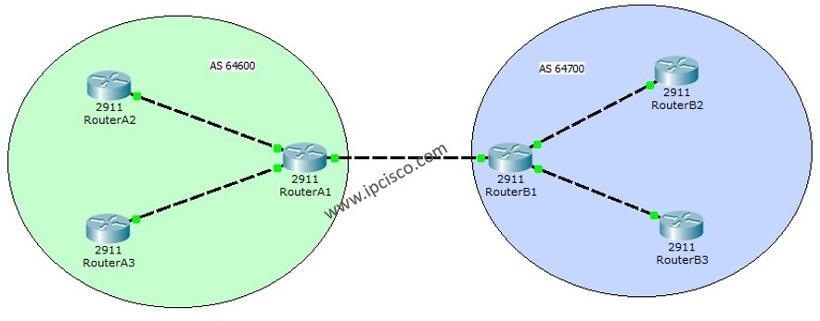

Table of Contents

[](https://ipcisco.com/lesson/bgp-configuration-example-with-packet-tracer/)

* [Packet Tracer BGP Configuration Example](https://ipcisco.com/lesson/bgp-configuration-example-with-packet-tracer/#Packet_Tracer_BGP_Configuration_Example)
  + [Interface Configurations for Packet Tracer BGP Configuration](https://ipcisco.com/lesson/bgp-configuration-example-with-packet-tracer/#Interface_Configurations_for_Packet_Tracer_BGP_Configuration)
  + [BGP Configurations for Packet Tracer BGP Configuration](https://ipcisco.com/lesson/bgp-configuration-example-with-packet-tracer/#BGP_Configurations_for_Packet_Tracer_BGP_Configuration)

## Packet Tracer BGP Configuration Example

To understand BGP (Border Gateway Protocol) better, we will make a basic Packet Tracer BGP Configuration example. Because of the limited numbers of commands available on Packet Tracer, we will have a very basic configuration for our Packet Tracer BGP Configuration example. Beside this, I will add some additional cofiguration steps that is needed for IBGP but we can not config ure on Packet Tracer.

In the configuration we will use two AS (Autonomous System) with 3 routers for each. We will use the private AS block (64512 to 65535) for this configuration, but in internet public AS numbers are used.

You can **DOWNLOAD** the **Packet Tracer** example with **.pkt** format [**HERE.**](https://www.ipcisco.com/wp-content/uploads/PT/eBGP.rar)

The topology that we will be used for our Packet Tracer BGP Configuration is below:

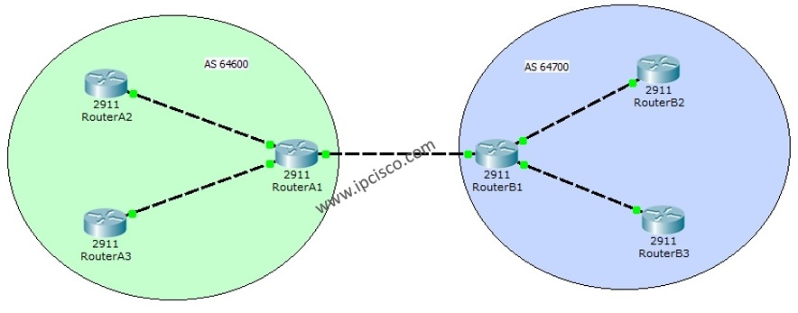

BGP Configuration Topology

For Packet Tracer BGP Configuration, firstly we need to configure the IP addresses of interfaces as other examples. To do this, as a better network engineering rule, firstly make your IP plan or, use the existing one. Acording to my basic IP plan, I used the below IPs for my interfaces.

Interfaces IP Addresses  
1.1.1.1  
2.2.2.2  
10.0.0.1  
10.0.0.2  
20.0.0.1  
20.0.0.2  
30.0.0.1  
30.0.0.2  
40.0.0.1  
40.0.0.2  
50.0.0.1  
50.0.0.2

### **Interface Configurations for Packet Tracer BGP Configuration**

**RouterA1 Interface Configuration**

RouterA1(config)# **interface loopback 0**

RouterA1(config-if)# **ip address 1.1.1.1 255.255.255.255**

RouterA1(config-if)# **no shutdown**

RouterA1(config-if)# **exit**

RouterA1(config)# **interface gigabitEthernet 0/0**

RouterA1(config-if)# **ip address 10.0.0.1 255.255.255.0**

RouterA1(config-if)# **no shutdown**

RouterA1(config-if)# **exit**

RouterA1(config)# **interface gigabitEthernet 0/1**

RouterA1(config-if)# **ip address 20.0.0.1 255.255.255.0**

RouterA1(config-if)# **no shutdown**

RouterA1(config)# **interface gigabitEthernet 0/2**

RouterA1(config-if)# **ip address 30.0.0.1 255.255.255.0**

RouterA1(config-if)# **no shutdown**

|  |
| --- |
|  |

**RouterB1 Interface Configuration**

RouterB1(config)# **interface loopback 0**

RouterB1(config-if)# **ip address 2.2.2.2 255.255.255.255**

RouterB1(config-if)# **no shutdown**

RouterB1(config-if)# **exit**

RouterB1(config)# **interface gigabitEthernet 0/0**

RouterB1(config-if)# **ip address 10.0.0.2 255.255.255.0**

RouterB1(config-if)# **no shutdown**

RouterB1(config-if)# **exit**

RouterB1(config)# **interface gigabitEthernet 0/1**

RouterB1(config-if)# **ip address 40.0.0.1 255.255.255.0**

RouterB1(config-if)# **no shutdown**

RouterB1(config-if)# **exit**

RouterB1(config)# **interface gigabitEthernet 0/2**

RouterB1(config-if)# **ip address 50.0.0.1 255.255.255.0**

RouterB1(config-if)# **no shutdown**

|  |
| --- |
|  |

**RouterA2 Interface Configuration**

RouterA2(config)# **interface gigabitEthernet 0/1**

RouterA2(config-if)# **ip address 20.0.0.2 255.255.255.0**

RouterA2(config-if)# **no shutdown**

|  |
| --- |
|  |

**RouterA3 Interface Configuration**

RouterA3(config)# **interface gigabitEthernet 0/2**

RouterA3(config-if)# **ip address 30.0.0.2 255.255.255.0**

RouterA3(config-if)# **no shutdown**

|  |
| --- |
|  |

**RouterB2 Interface Configuration**

RouterB2(config)# **interface gigabitEthernet 0/1**

RouterB2(config-if)# **ip address 40.0.0.2 255.255.255.0**

RouterB2(config-if)# **no shutdown**

|  |
| --- |
|  |

**RouterB3 Interface Configuration**

RouterB3(config)# **interface gigabitEthernet 0/2**

RouterB3(config-if)# **ip address 50.0.0.2 255.255.255.0**

RouterB3(config-if)# **no shutdown**

|  |
| --- |
|  |

### **BGP Configurations for Packet Tracer BGP Configuration**

The exact important point of Packet Tracer BGP Configuration is here. The configuration made in this part, is for the BGP.

As I said before, because of the Packet Tracer ‘s command limit, in the configuration file, th IBGP parts are not configured, but writen here (ibgp neighbourship and route reflector commands).

RouterA1(config)# **router bgp 64600**

RouterA1(config-router)# **neighbor 10.0.0.2 remote-as 64700**

RouterA1(config-router)# **neighbor 20.0.0.2 remote-as 64600**

RouterA1(config-router)# **neighbor 30.0.0.2 remote-as 64600**

RouterA1(config-router)# **neighbor 20.0.0.2 route-reflector-client**

RouterA1(config-router)# **neighbor 30.0.0.2 route-reflector-client**

RouterA1(config-router)# **network 20.0.0.0 mask 255.255.255.0**

RouterA1(config-router)# **network 30.0.0.0 mask 255.255.255.0**

# ISIS Configuration Example on Cisco IOS

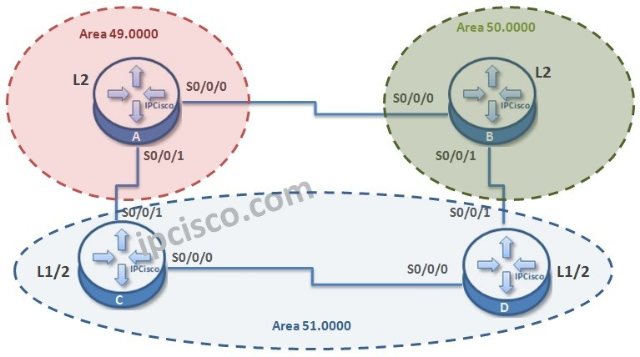

In this Cisco ISIS configuration example, we will configure an ISIS domain and see how to establish ISIS Routing.

For our example we will use the below four-routered topology. Here, we will have 3 different area. We are using multi area model to show you the link level configurations.

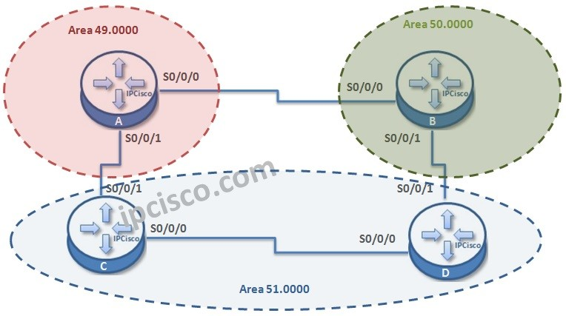

Let’s start the ISIS configuration.

Firstly we will create the router ISIS process with the value “1” and we will give a “net” address to each router. After that we will set the router type. By default all routers are Level 1/2 .  
By the way, let’s remember ISIS router types quickly;

• **L1 routers**, establish neighbourship with only the routers in the same area.  
• **L2 routers**, establish neighbourship with routers in different areas or in the same area.  
• **L1/2 routers**, establish neighbourship with routers in any area.

How about LSDBs?

• L1 routers have **Level-1 LSDB** for the area  
• L2 router s have **Level-2 LSD** for inter-area (between areas)  
• L1 routers has **two separate LSDB** for both Level-1 and Level-2

Router A # **config terminal**

Router A (config) # **router isis 1**

Router A (config-rtr)# **net 49.0000.0000.0000.AAAA.00**

Router A (config-rtr)# **is-type level-2-only**

|  |
| --- |
|  |

Router B # **config terminal**

Router B (config) # **router isis 1**

Router B (config-rtr)# **net 50.0000.0000.0000.BBBB.00**

Router B (config-rtr)# **is-type level-2-only**

|  |
| --- |
|  |

Router C # **config terminal**

Router C (config) # **router isis 1**

Router C (config-rtr)# **net 51.0000.0000.0000.CCCC.00**

Router C (config-rtr)# **is-type level-1-2**

|  |
| --- |
|  |

Router D # **config terminal**

Router D (config) # **router isis 1**

Router D (config-rtr)# **net 51.0000.0000.0000.DDDD.00**

Router D (config-rtr)# **is-type level-1-2**

EIGRP Configuration With Packet Tracer

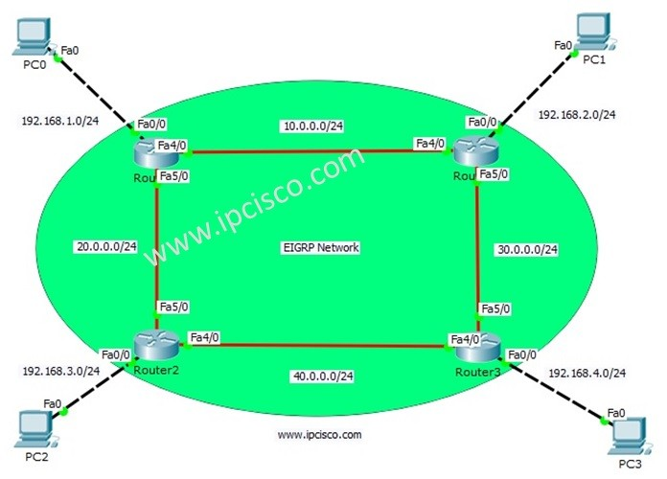

Table of Contents

[](https://ipcisco.com/lesson/eigrp-configuration-with-packet-tracer/)

* [Packet Tracer EIGRP Configuration](https://ipcisco.com/lesson/eigrp-configuration-with-packet-tracer/#Packet_Tracer_EIGRP_Configuration)
* [IP Configurations For EIGRP Configuration](https://ipcisco.com/lesson/eigrp-configuration-with-packet-tracer/#IP_Configurations_For_EIGRP_Configuration)
* [EIGRP Configuration on Routers](https://ipcisco.com/lesson/eigrp-configuration-with-packet-tracer/#EIGRP_Configuration_on_Routers)
* [Configuration Verification](https://ipcisco.com/lesson/eigrp-configuration-with-packet-tracer/#Configuration_Verification)

Packet Tracer EIGRP Configuration

[**EIGRP (Enhanced Interior Gateway Routing Protocol)**](https://ipcisco.com/lesson/eigrp-enhanced-interior-gateway-routing-protocol-ccnp/), is a Cisco Proprietary **Hybrid Routing Protocol**. The **configuration** of **EIGRP**is similar to other **Routing Protocols**. In this example, we will configure **EIGRP on Packet Tracer with Cisco Routers.**.

With this **EIGRP Config**, we will learn important Cisco **EIGRP Commands** on Cisco Packet Tracer. For our **EIGRP Config Example**, we will use the below topology consist of four routers and four PCs on Packet Tracer.

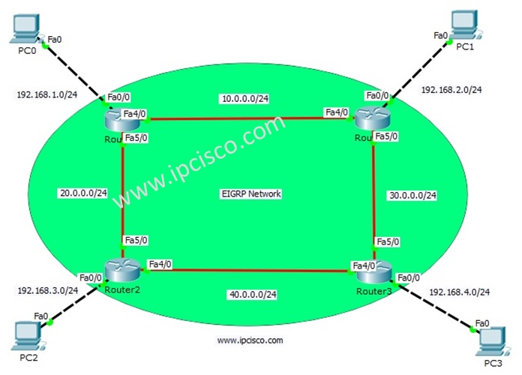

*EIGRP Configuration Topology*

You can **DOWNLOAD**the **Cisco Packet Tracer** example with **.pkt** format at the **End of This Lesson**.

You can also **DOWNLOAD**all the **Packet Tracer** examples with **.pkt** format in [**Packet Tracer Labs**](https://ipcisco.com/cisco-packet-tracer-configuration-examples/) section.

IP Configurations For EIGRP Configuration

For any Packet Tracer Configuration Exmaple, firstly we should configure IP addresses. So, in this **EIGRP Configuration**, let’s firtly configure IP addresses of  the routers and PCs. You can find these ip addresses below:

**PC0:** 192.168.1.1 255.255.255.0 GW:192.168.1.2  
**PC1:** 192.168.2.1 255.255.255.0 GW:192.168.2.2  
**PC2:** 192.168.3.1 255.255.255.0 GW:192.168.3.2  
**PC3:** 192.168.4.1 255.255.255.0 GW:192.168.4.2

We will start our **EIGRP Packet Tracer Configuration** with Router 0 and we will continue with Router1, Router2 and Router3 orderly. Let’s start!

Router0(config)# **interface FastEthernet0/0**

Router0(config-if)# **ip address 192.168.1.2 255.255.255.0**

Router0(config-if)# **no shutdown**

Router0(config-if)# **exit**

Router0(config)# **interface FastEthernet4/0**

Router0(config-if)# **ip address 10.0.0.1 255.255.255.0**

Router0(config-if)# **no shutdown**

Router0(config-if)# **exit**

Router0(config)# **interface FastEthernet5/0**

Router0(config-if)# **ip address 20.0.0.1 255.255.255.0**

Router0(config-if)# **no shutdown**

Router0(config-if)# **end**

Router0# **copy running-config startup-config**

|  |
| --- |
|  |

[**CISCO HANDS ON COURSE LESSONS**](https://ipcisco.com/cisco-hands-on-course-with-packet-tracer/)

Router1(config)# **interface FastEthernet0/0**

Router1(config-if)# **ip address 192.168.2.2 255.255.255.0**

Router1(config-if)# **no shutdown**

Router1(config-if)# **exit**

Router1(config)# **interface FastEthernet4/0**

Router1(config-if)# **ip address 10.0.0.2 255.255.255.0**

Router1(config-if)# **no shutdown**

Router1(config-if)# **exit**

Router1(config)# **interface FastEthernet5/0**

Router1(config-if)# **ip address 30.0.0.1 255.255.255.0**

Router1(config-if)# **no shutdown**

Router1(config-if)# **end**

Router1# **copy running-config startup-config**

|  |
| --- |
|  |

Router2(config)# **interface FastEthernet0/0**

Router2(config-if)# **ip address 192.168.3.2 255.255.255.0**

Router2(config-if)# **no shutdown**

Router2(config-if)# **exit**

Router2(config)# **interface FastEthernet4/0**

Router2(config-if)# **ip address 40.0.0.1 255.255.255.0**

Router2(config-if)# **no shutdown**

Router2(config-if)# **exit**

Router2(config)# **interface FastEthernet5/0**

Router2(config-if)# **ip address 20.0.0.2 255.255.255.0**

Router2(config-if)# **no shutdown**

Router2(config-if)# **end**

Router2# **copy running-config startup-config**

|  |
| --- |
|  |

Router3(config)# **interface FastEthernet0/0**

Router3(config-if)# **ip address 192.168.4.2 255.255.255.0**

Router3(config-if)# **no shutdown**

Router3(config-if)# **exit**

Router3(config)# **interface FastEthernet4/0**

Router3(config-if)# **ip address 40.0.0.2 255.255.255.0**

Router3(config-if)# **no shutdown**

Router3(config-if)# **exit**

Router3(config)# **interface FastEthernet5/0**

Router3(config-if)# **ip address 30.0.0.2 255.255.255.0**

Router3(config-if)# **no shutdown**

Router3(config-if)# **end**

Router3# **copy running-config startup-config**

|  |
| --- |
|  |

EIGRP Configuration on Routers

For **EIGRP Configuration**, we will use **Autonomous System Number**. We will use this number with “**router eigrp**” command. After this **command**, we will be under router configuration mode. We will add **networks**that run EIGRP one by one. Lastly we will add “**no auto-summary**” command to avoid **automatic summarization** on routing table.

Firstly, let’s start our **EIGRP Config** with Router0 and then **configure EIGRP** on the other Routers.

Here, our EIGRP Autonomous number will be **100**. And for Router0,**192.168.1.0, 10.0.0.0, 20.0.0.0** network  will be added under this EIGRP process. These are the directly connected networks to Router0.

Router0(config)# **router eigrp 100**

Router0(config-router)# **network 192.168.1.0**

Router0(config-router)# **network 10.0.0.0**

Router0(config-router)# **network 20.0.0.0**

Router0(config-router)# **no auto-summary**

Router0(config-router)# **end**

Router0# **copy running-config startup-config**

|  |
| --- |
|  |

The similar configuration will be done on Router1 also. Here, only the networks will be changed. The direclty connected networks to Router1 will be added.

Router1(config)# **router eigrp 100**

Router1(config-router)# **network 192.168.2.0**

Router1(config-router)# **network 10.0.0.0**

Router1(config-router)# **network 30.0.0.0**

Router1(config-router)# **no auto-summary**

Router1(config-router)# **end**

Router1# **copy running-config startup-config**

|  |
| --- |
|  |

For Router2 and Router3 the similar **Cisco EIGRP Configuration** will be done. Only ne added networks will be changed. Because each router has different directly connected networks.

Router2(config)# **router eigrp 100**

Router2(config-router)# **network 192.168.3.0**

Router2(config-router)# **network 20.0.0.0**

Router2(config-router)# **network 40.0.0.0**

Router2(config-router)# **no auto-summary**

Router2(config-router)# **end**

Router2# **copy running-config startup-config**

|  |
| --- |
|  |

Router3(config)# **router eigrp 100**

Router3(config-router)# **network 192.168.4.0**

Router3(config-router)# **network 30.0.0.0**

Router3(config-router)# **network 40.0.0.0**

Router3(config-router)# **no auto-summary**

Router3(config-router)# **end**

Router3# **copy running-config startup-config**

|  |
| --- |
|  |

Configuration Verification

After our Packet Tracer Configuartion, now let’s **verify**our **EIGRP Configuration** with **EIGRP Show Commands**. Here, we will check this only on some routers, not on all of them. So what are these verification commands? Some of thes eEIGRP verification commands are given below:

* **show ip eigrp**
* **show ip eigrp neighbors**
* **show ip eigrp interfaces**
* **show ip eigrp topology**
* **show ip route eigrp**
* **show ip protocols**

Now, let’s chekc each of these commands on Cisco routers.

When we use “**show ip eigrp ?**” command, we can see our eigrp options that we can use on Packet Tracer.

Router# **show ip eigrp ?** interfaces IP-EIGRP interfaces neighbors IP-EIGRP neighbors topology IP-EIGRP Topology Table traffic IP-EIGRP Traffic Statistics

Here, firstly we will check **EIGRP neighbours** of Router0 and Router1. We will see this neighbors with “**show ip eigrp neighbors**” command.

Router0# **show ip eigrp neighbors**

IP-EIGRP neighbors for process 100

H Address Interface Hold Uptime SRTT RTO Q Seq

(sec) (ms) Cnt Num

0 10.0.0.2 Fa4/0 14 00:14:53 40 1000 0 12

1 20.0.0.2 Fa5/0 12 00:14:53 40 1000 0 11

|  |
| --- |
|  |

Router1# **show ip eigrp neighbors**

IP-EIGRP neighbors for process 100

H Address Interface Hold Uptime SRTT RTO Q Seq

(sec) (ms) Cnt Num

0 30.0.0.2 Fa5/0 14 00:16:57 40 1000 0 11

1 10.0.0.1 Fa4/0 13 00:16:57 40 1000 0 13

|  |
| --- |
|  |

We can verify the **EIGRP interfaces** with “**show ip eigrp interfaces**” command.

Router0# **show ip eigrp interfaces**

IP-EIGRP interfaces for process 100

Xmit Queue Mean Pacing Time Multicast Pending

Interface Peers Un/Reliable SRTT Un/Reliable Flow Timer Routes

Fa4/0 1 0/0 1236 0/10 0 0

Fa5/0 1 0/0 1236 0/10 0 0

Fa0/0 0 0/0 1236 0/10 0 0

|  |
| --- |
|  |

Router1# **show ip eigrp interfaces**

IP-EIGRP interfaces for process 100

Xmit Queue Mean Pacing Time Multicast Pending

Interface Peers Un/Reliable SRTT Un/Reliable Flow Timer Routes

Fa4/0 1 0/0 1236 0/10 0 0

Fa5/0 1 0/0 1236 0/10 0 0

Fa0/0 0 0/0 1236 0/10 0 0

|  |
| --- |
|  |

We can see the whole Topology Table of Router0 and Router1 with **show ip eigrp topology**command.

Router0# **show ip eigrp topology**

IP-EIGRP Topology Table for AS 100/ID(192.168.1.2)

Codes: P - Passive, A - Active, U - Update, Q - Query, R - Reply,

r - Reply status

P 10.0.0.0/24, 1 successors, FD is 28160

via Connected, FastEthernet4/0

P 20.0.0.0/24, 1 successors, FD is 28160

via Connected, FastEthernet5/0

P 30.0.0.0/24, 1 successors, FD is 30720

via 10.0.0.2 (30720/28160), FastEthernet4/0

P 40.0.0.0/8, 1 successors, FD is 30720

via 20.0.0.2 (30720/28160), FastEthernet5/0

P 192.168.1.0/24, 1 successors, FD is 28160

via Connected, FastEthernet0/0

P 192.168.2.0/24, 1 successors, FD is 30720

via 10.0.0.2 (30720/28160), FastEthernet4/0

P 192.168.3.0/24, 1 successors, FD is 30720

via 20.0.0.2 (30720/28160), FastEthernet5/0

P 192.168.4.0/24, 1 successors, FD is 33280

via 10.0.0.2 (33280/30720), FastEthernet4/0

|  |
| --- |
|  |

Router1# **show ip eigrp topology**

IP-EIGRP Topology Table for AS 100/ID(192.168.2.2)

Codes: P - Passive, A - Active, U - Update, Q - Query, R - Reply,

r - Reply status

P 10.0.0.0/24, 1 successors, FD is 28160

via Connected, FastEthernet4/0

P 20.0.0.0/24, 1 successors, FD is 30720

via 10.0.0.1 (30720/28160), FastEthernet4/0

P 30.0.0.0/24, 1 successors, FD is 28160

via Connected, FastEthernet5/0

P 40.0.0.0/8, 1 successors, FD is 30720

via 30.0.0.2 (30720/28160), FastEthernet5/0

P 192.168.1.0/24, 1 successors, FD is 30720

via 10.0.0.1 (30720/28160), FastEthernet4/0

P 192.168.2.0/24, 1 successors, FD is 28160

via Connected, FastEthernet0/0

P 192.168.3.0/24, 1 successors, FD is 33280

via 10.0.0.1 (33280/30720), FastEthernet4/0

P 192.168.4.0/24, 1 successors, FD is 30720

via 30.0.0.2 (30720/28160), FastEthernet5/0

# Cisco Single Area OSPF Configuration

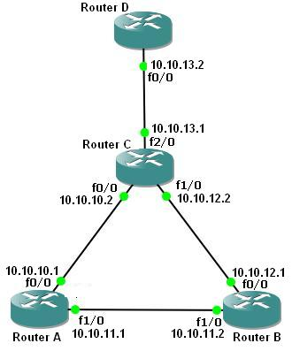

Table of Contents

[](https://ipcisco.com/lesson/cisco-single-area-ospf-configuration/)

* [OSPF Cisco Configuration](https://ipcisco.com/lesson/cisco-single-area-ospf-configuration/#OSPF_Cisco_Configuration)
* [Cisco OSPF Configuration Steps](https://ipcisco.com/lesson/cisco-single-area-ospf-configuration/#Cisco_OSPF_Configuration_Steps)
  + [Enabling OSPF Process](https://ipcisco.com/lesson/cisco-single-area-ospf-configuration/#Enabling_OSPF_Process)
  + [Adding OSPF Networks](https://ipcisco.com/lesson/cisco-single-area-ospf-configuration/#Adding_OSPF_Networks)
  + [Saving OSPF Config](https://ipcisco.com/lesson/cisco-single-area-ospf-configuration/#Saving_OSPF_Config)
  + [OSPF Config on Router B](https://ipcisco.com/lesson/cisco-single-area-ospf-configuration/#OSPF_Config_on_Router_B)
  + [OSPF Config on Router C](https://ipcisco.com/lesson/cisco-single-area-ospf-configuration/#OSPF_Config_on_Router_C)

## OSPF Cisco Configuration

[**OSPF (Open Shortest Path First)**](https://ipcisco.com/lesson/ospfopen-shortest-path-first-overview-ccnp/) protocol is a well-known routing protocol that is widely used today. To configure a network for **OSPF**properly there are some steps. For basic **OSPF Cisco Configuration**, the following scenario will be a good example.

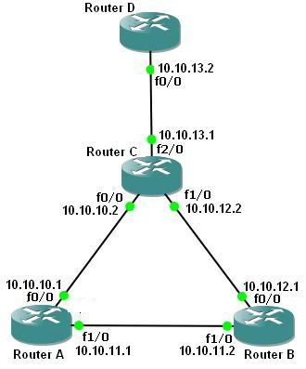

Single Area OSPF Configuration Topology

You can also learn [**DHCP Server Configuration With Packet Tracer**](https://ipcisco.com/lesson/router-dhcp-configuration-with-packet-tracer-ccna/)

## Cisco OSPF Configuration Steps

First of all, we will configure the routers’ interfaces. After that we will configure **OSPF**as our **Routing Protocol**. Here we assume that all the interfaces including loopback interfaces, their speed, duplex and descriptions have been configured.

To do **OSPF Cisco Configuration**, follow the below steps:

### **Enabling OSPF Process**

In the router A, we will enable **OSPF**Process, with Process Number “**1**“.

**A(config)# router ospf 1  
A(config-router)#**

### **Adding OSPF Networks**

After enabling **OSPF**process on our Cisco Router A, then, we will add our networks that will be in OSPF network with their wildcard masks.

**A(config-router)# network 10.10.10.0 0.0.0.255 area 0  
A(config-router)# network 10.10.11.0 0.0.0.255 area 0  
A(config-router)# end**

### **Saving OSPF Config**

To save our configuration, we will use “**copy running-config startup-config**” command.

**A # copy running-config startup-config**

### **OSPF Config on Router B**

We will configure Router B like Router A. We will enable **OSPF**and then add OSPF Networks.

**B(config)# router ospf 1  
B(config-router)# network 10.10.11.0 0.0.0.255 area 0  
B(config-router)# network 10.10.12.0 0.0.0.255 area 0  
B(config-router)# exit  
B # copy running-config startup-config**

### **OSPF Config on Router C**

We will configure Router C like Router A. We will enable **OSPF**and then add OSPF Networks.

**C(config)# router ospf 1  
C(config-router)# network 10.10.10.0 0.0.0.255 area 0  
C(config-router)# network 10.10.12.0 0.0.0.255 area 0  
C(config-router)# network 10.10.13.0 0.0.0.255 area 0  
C(config-router)# end  
C# copy running-config startup-config**

# RIP Configuration With Packet Tracer

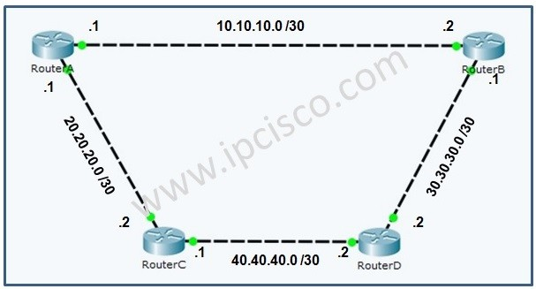

## Packet Tracer RIP Configuration

In this article, we will focus on how to configure RIP (Routing Information Protocol) on Cisco Routers. We will learn the commands for Cisco RIP Configuration.

Generally in all network courses, RIP is used to explain routing protocol configuration basically. This is because of its basic configuration.  
  
You can **DOWNLOAD**the **Packet Tracer** example with **.pkt** format [**HERE**.](https://ipcisco.com/wp-content/uploads/rip/basic-rip-configuration.rar)

For our example, we will use the following basic topology:

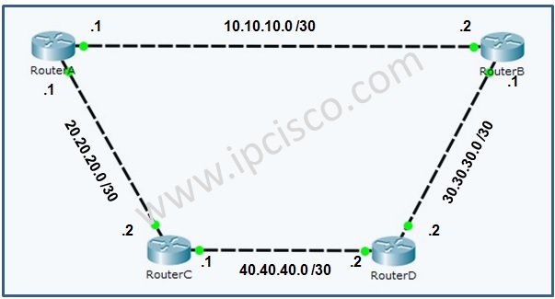

RIP Example Topology

With this topology, the IP addresses are configured. We will pass the configuration of IP addresses and continue only the routing protocol, RIP configuration.

Before the configuration of RIP, let’s check the routing table of RouterA.

RouterA# **show ip route**

Codes: C - connected, S - static, I - IGRP, R - RIP, M - mobile, B - BGP

D - EIGRP, EX - EIGRP external, O - OSPF, IA - OSPF inter area

N1 - OSPF NSSA external type 1, N2 - OSPF NSSA external type 2

E1 - OSPF external type 1, E2 - OSPF external type 2, E - EGP

i - IS-IS, L1 - IS-IS level-1, L2 - IS-IS level-2, ia - IS-IS inter area

\* - candidate default, U - per-user static route, o - ODR

P - periodic downloaded static route

Gateway of last resort is not set

10.0.0.0/30 is subnetted, 1 subnets

C 10.10.10.0 is directly connected, FastEthernet0/0

20.0.0.0/30 is subnetted, 1 subnets

C 20.20.20.0 is directly connected, FastEthernet0/1

|  |
| --- |
|  |

RouterA# **show ip protocols**

|  |
| --- |
|  |

RouterA# **show ip int brief**

Interface IP-Address OK? Method Status Protocol

FastEthernet0/0 10.10.10.1 YES manual up up

FastEthernet0/1 20.20.20.1 YES manual up up

Vlan1 unassigned YES unset administratively down down

|  |
| --- |
|  |

As you can see, there is only directly connected neighbours in the routing table of RouterA. RouterA do not know any other networks, also RouterD. There is no routing protocol configured on RouterA.  
  
Firstly we will configure RouterA with**network**commands under **rip process**. By doing this, we will add networks under RIP process.

RouterA(config)# **router rip**

RouterA(config-router)# **version 2**

RouterA(config-router)# **network 10.10.10.0**

RouterA(config-router)# **network 20.20.20.0**

# Static Route Configuration on Cisco Routers

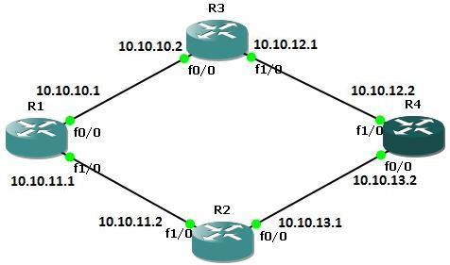

## Cisco Static Route Configuration

To send the traffic to the destination we can use two types of routing. Static and [**Dynamic routing**](https://ipcisco.com/lesson/dynamic-routing-protocols-ccnp/). Static route tell the network devices about exact location.Beside, static routers can work well with small networks. For large scale networks dynamic routing will be better choice.Here we will focus static routing. The below example will explain the configuration of the static routes.

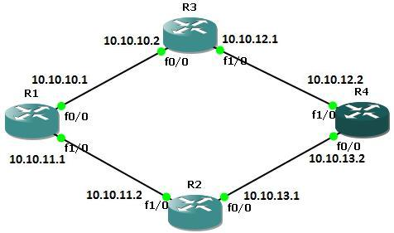

**Configure the Static Routes on Router A**

First run the command show ip route to view the IP routing table for router A before defining static routes

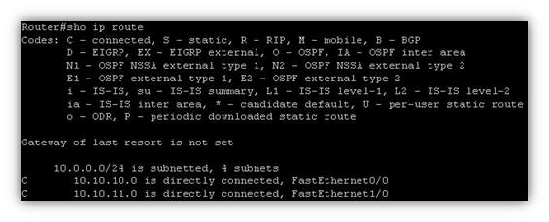

RouterA# **configure terminal**

RouterA(config)# **ip route 10.10.12.0 255.255.255.0 10.10.10.2**

RouterA(config)# **ip route 10.10.13.0 255.255.255.0 10.10.11.2**

RouterA(config)# **exit**

|  |
| --- |
|  |

If we give show ip route command on router A to view the IP routing table we will see both directly connected and static routes detail.

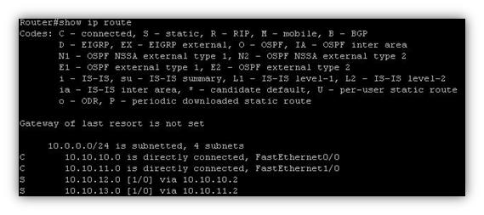

**Configure the Static Routes on Router B**

First run the command show ip route to view the IP routing table for router B before defining static routes

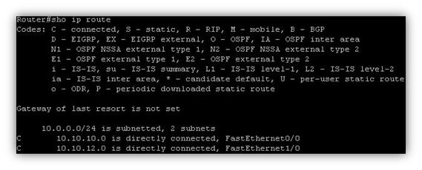

RouterB# **configure terminal**

RouterB(config)# **ip route 10.10.11.0 255.255.255.0 10.10.10.1**

RouterB(config)# **ip route 10.10.13.0 255.255.255.0 10.10.12.2**

RouterB(config)# **exit**

|  |
| --- |
|  |

If we give show ip route command on router B to view the IP routing table we will see both directly connected and static routes detail.

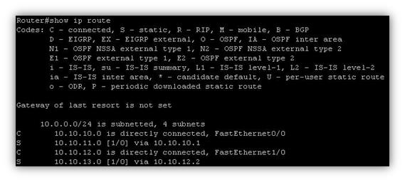

**Configure the Static Routes on Router C**

First run the command show ip route to view the IP routing table for router C before defining static routes.

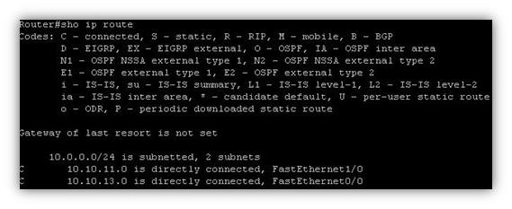

RouterC# **configure terminal**

# ISIS For IPv6 Configuration Example on Cisco IOS



## How to Configure ISIS For IPv6 on Cisco?

In this **Cisco**[**ISIS for IPv6**](https://ipcisco.com/lesson/isis-for-ipv6-ccie/) configuration example, we will configure [**ISIS**](https://ipcisco.com/lesson/is-is/)**with IPv6** extension configuration commands.  
  
For our example we will use the below four-routered topology. Here, we will have 3 different area. There is a Single Topology and Multi-Topology configurations with ISIS for IPv6. We will give an example to Multi-Topology here.



Let’s start the **ISIS for IPv6** configuration.

Firstly, we will enable [**IPv6**](https://ipcisco.com/lesson/ipv6-and-ipv6-addresses/)**routing** on each routers. We will do this with “**ipv6 unicast-routing**” command.

Router A # **config terminal**

Router A (config) # **ipv6 unicast-routing**

|  |
| --- |
|  |

Router B # **config terminal**

Router B (config) # **ipv6 unicast-routing**

|  |
| --- |
|  |

Router C # **config terminal**

Router C (config) # **ipv6 unicast-routing**

|  |
| --- |
|  |

Router D # **config terminal**

Router D (config) # **ipv6 unicast-routing**

|  |
| --- |
|  |

Now, **IPv6 Routing** is enabled on each router. It is time to configure router ISIS process. Here, we will use a name for ISIS process. This name is “**ABC**”. Beside, we will give [**NET Addresses**](https://ipcisco.com/lesson/is-is-addresses/) to the interface and we will configure the router global level.

By the way, let’s remember the router levels with a shape.

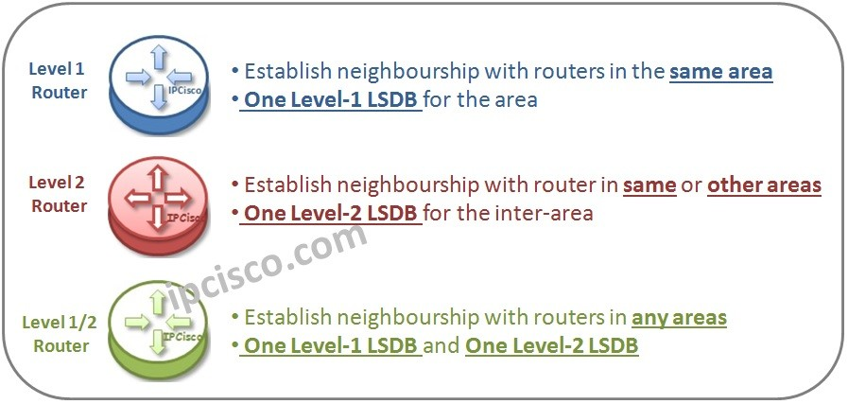

Router A (config) # **router isis ABC**

Router A (config-rtr)# **net 49.0000.0000.0000.AAAA.00**

Router A (config-rtr)# **is-type level-2-only**

|  |
| --- |
|  |

Router B (config) # **router isis ABC**

Router B (config-rtr)# **net 50.0000.0000.0000.BBBB.00**

Router B (config-rtr)# **is-type level-2-only**

# EIGRP For IPv6 Configuration On Cisco IOS

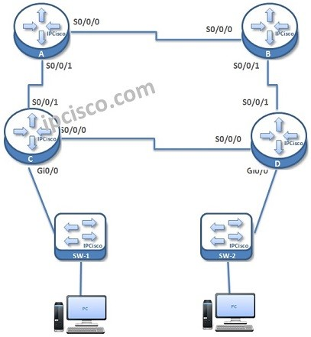

# EIGRP For IPv6 Configuration On Cisco IOS

**EIGRP for IPv6** is one of the most used routing protocol with **IPv6**. In this example, we will see how to configure **EIGRP for IPv6** on **Cisco**routers.

For our example, we will use the topology below.

Here, simply we have four routers connected serially eachother and two switches and PCs are connected to this routers.

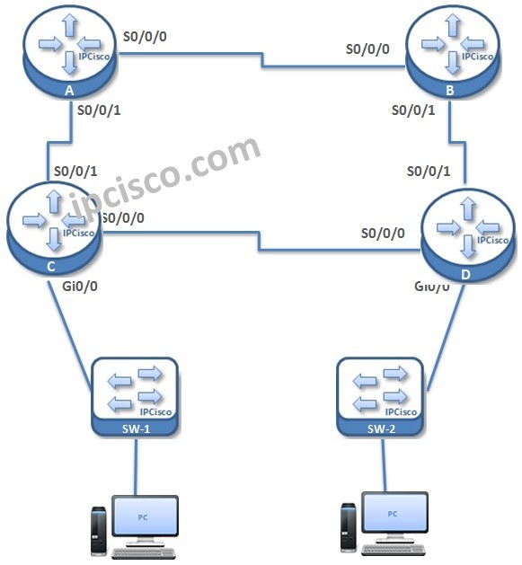

As a summary, let’s check waht will we do for EIGRP for IPv6 configuration:

**1. Global IPv6 Enable on Routers  
2. EIGRP for IPv6 Process Creation  
3. Router-ID Assign  
4. EIGRP Process addition under Interfaces  
5. Passive interface configuraiton  
6. Verification**

Let’s see each of this **EIGRP for IPv6** configuration example one by one.

First of all we enable IPv6 routing on all routers. Because, by default ipv6 routing is not enabled.

Router A # **config terminal**

Router A (config) # **ipv6 unicast-routing**

|  |
| --- |
|  |

Router B # **config terminal**

Router B (config) # **ipv6 unicast-routing**

|  |
| --- |
|  |

Router C # **config terminal**

Router C (config) # **ipv6 unicast-routing**

|  |
| --- |
|  |

Router D # **config terminal**

Router D (config) # **ipv6 unicast-routing**

|  |
| --- |
|  |

After enabling IPv6 routing, it is time to configure EIGRP for IPv6. For this configuration we will use “ipv6 router eigrp -process number-” configuration command. We will create the EIGRP process on the Router. And we will no shutdown this eigrp process.

Under IPv6 eigrp process, we will also configure a router ID. This router ID will be in IPv4 format like the one used in EIGRP before. Here our routing Ids will be 1.1.1.1, 2.2.2.2, 3.3.3.3 and 4.4.4.4 simply.

Router A # **config terminal**

Router A (config) # **ipv6 router eigrp 100**

Router A (config-rtr)# **no shutdown**

Router A (config-rtr)# **eigrp router-id 1.1.1.1**

|  |
| --- |
|  |

Router B # **config terminal**

Router B (config) # **ipv6 router eigrp 100**

Router B (config-rtr)# **no shutdown**

Router B (config-rtr)# **eigrp router-id 2.2.2.2**

|  |
| --- |
|  |

# OSPFv3 Configuration Example on Cisco IOS

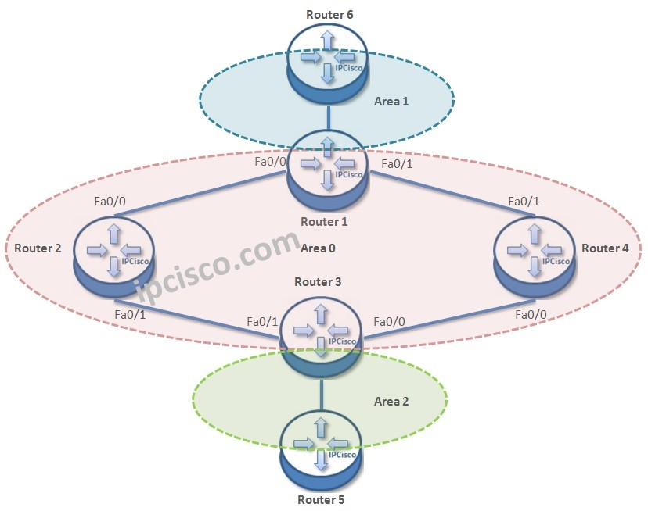

Table of Contents

[](https://ipcisco.com/lesson/ospfv3-configuration-example-on-cisco-ios/)

* [OSPFv3 Cisco Configuration](https://ipcisco.com/lesson/ospfv3-configuration-example-on-cisco-ios/#OSPFv3_Cisco_Configuration)
  + [Enabling Global IPv6 Routing](https://ipcisco.com/lesson/ospfv3-configuration-example-on-cisco-ios/#Enabling_Global_IPv6_Routing)
  + [Enabling Interfaces for IPv6](https://ipcisco.com/lesson/ospfv3-configuration-example-on-cisco-ios/#Enabling_Interfaces_for_IPv6)
  + [IPv6 Address Configuration](https://ipcisco.com/lesson/ospfv3-configuration-example-on-cisco-ios/#IPv6_Address_Configuration)
  + [Router ID Configuration](https://ipcisco.com/lesson/ospfv3-configuration-example-on-cisco-ios/#Router_ID_Configuration)

## OSPFv3 Cisco Configuration

[**OSPFv3**](https://ipcisco.com/lesson/ospfv3-open-shortest-path-first-version-3-ccnp/) is the [**IPv6**](https://ipcisco.com/course/ipv6-course/)cabaple version of OSPF. The previous version of OSPF was [**OSPFv2**](https://ipcisco.com/lesson/ospfopen-shortest-path-first-overview-ccnp/). **OSPFv2** is for IPv4.  
  
Here, we will configure **OSPFv3**for the below topology. As you can see, there are three areas and six routers in this topology.



For OSPFv3 Configuration, we will follow the below steps one by one:

**1. Enabling Global IPv6 Routing  
2. Enabling Interfaces for IPv6  
3. IPv6 Address Configuration  
4. Configuring OSPFv3 Process  
5. Router ID Configuration  
6. Adding Interfaces to OSPFv3 Process and Areas  
7. Clear ipv6 ospf process  
8. Verification**

Now, let’s go to each COnfiguration steps one by one.

### **Enabling Global IPv6 Routing**

Firstly, we will enable global **IPv6** Routing on each Router with “**ipv6 unicast-routing**” command.

Router 1 # **config terminal**

Router 1 (config) # **ipv6 unicast-routing**

|  |
| --- |
|  |

Router 2 # **config terminal**

Router 2 (config) # **ipv6 unicast-routing**

|  |
| --- |
|  |

Router 3 # **config terminal**

Router 3 (config) # **ipv6 unicast-routing**

|  |
| --- |
|  |

Router 4 # **config terminal**

Router 4 (config) # **ipv6 unicast-routing**

|  |
| --- |
|  |

Router 5 # **config terminal**

Router 5 (config) # **ipv6 unicast-routing**

|  |
| --- |
|  |

Router 6 # **config terminal**

Router 6 (config) # **ipv6 unicast-routing**

|  |
| --- |
|  |

### **Enabling Interfaces for IPv6**

Secondly, we will enable IPv6 under interfaces with “**ipv6 enable**” command.

Router 1 (config) # **interface fa0/0**

Router 1 (config-if) # **ipv6 enable**

Router 1 (config-if) # **interface fa0/1**

Router 1 (config-if) # **ipv6 enable**

Router 1 (config-if) # **interface fa0/1**

Router 1 (config-if) # **ipv6 enable**

|  |
| --- |
|  |

Router 2 (config) # **interface fa0/0**

Router 2 (config-if) # **ipv6 enable**

Router 2 (config-if) # **interface fa0/1**

Router 2 (config-if) # **ipv6 enable**

|  |
| --- |
|  |

Router 3 (config) # **interface fa0/0**

Router 3 (config-if) # **ipv6 enable**

Router 3 (config-if) # **interface fa0/1**

Router 3 (config-if) # **ipv6 enable**

Router 3 (config-if) # **interface fa0/1**

Router 3 (config-if) # **ipv6 enable**

|  |
| --- |
|  |

Router 4 (config) # **interface fa0/0**

Router 4 (config-if) # **ipv6 enable**

Router 4 (config-if) # **interface fa0/1**

Router 4 (config-if) # **ipv6 enable**

|  |
| --- |
|  |

Router 5 (config) # **interface fa0/0**

Router 5 (config-if) # **ipv6 enable**

|  |
| --- |
|  |

Router 6 (config) # **interface fa0/0**

Router 6 (config-if) # **ipv6 enable**

|  |
| --- |
|  |

### **IPv6 Address Configuration**

In the third step, we will do the **IPv6 address configuration/strong>. We will use “ipv6 address -ipv6address- eui-64“ commands. The**[**Link-local addresses**](https://ipcisco.com/lesson/ipv6-link-local-address/)**required for neighbourship, will produce Link-local addresses with this command.**

**Router 1 (config) # interface fa0/0**

**Router 1 (config-if) # ipv6 address 2001:1234:0:111::1/64 eui-64**

**Router 1 (config-if) # interface fa0/1**

**Router 1 (config-if) # ipv6 address 2001:1234:0:222::1/64 eui-64**

**Router 1 (config-if) # interface fa0/1**

**Router 1 (config-if) # ipv6 address 2001:1234:0:555::1/64 eui-64**

|  |
| --- |
|  |

**Router 2 (config) # interface fa0/0**

**Router 2 (config-if) # ipv6 address 2001:1234:0:111::2/64 eui-64**

**Router 2 (config-if) # interface fa0/1**

**Router 2 (config-if) # ipv6 address 2001:1234:0:333::1/64 eui-64**

|  |
| --- |
|  |

**Router 3 (config) # interface fa0/0**

**Router 3 (config-if) # ipv6 address 2001:1234:0:444::2/64 eui-64**

**Router 3 (config-if) # interface fa0/1**

**Router 3 (config-if) # ipv6 address 2001:1234:0:333::2/64 eui-64**

**Router 3 (config-if) # interface fa0/1**

**Router 3 (config-if) # ipv6 address 2001:1234:0:666::1/64 eui-64**

|  |
| --- |
|  |

**Router 4 (config) # interface fa0/0**

**Router 4 (config-if) # ipv6 address 2001:1234:0:444::1/64 eui-64**

**Router 4 (config-if) # interface fa0/1**

**Router 4 (config-if) # ipv6 address 2001:1234:0:222::2/64 eui-64**

|  |
| --- |
|  |

**Router 5 (config) # interface fa0/0**

**Router 5 (config-if) # ipv6 address 2001:1234:0:555::2/64 eui-64**

|  |
| --- |
|  |

**Router 6 (config) # interface fa0/0**

**Router 6 (config-if) # ipv6 address 2001:1234:0:666::2/64 eui-64**

|  |
| --- |
|  |

### **Router ID Configuration**

**Now, it is time to configure OSPFv3 process under each router. We will use the process number 1 here. Beside, we will configure a router ID in IPv4 format. Because for both OSPv2 and OSPv3, Router ID is in IPv4 format.**

# RIPng Configuration Example on Cisco IOS

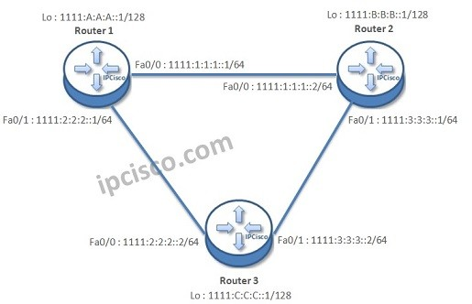

Table of Contents

[](https://ipcisco.com/lesson/ripng-configuration-example-on-cisco-ios/)

* [RIPng Cisco Configuration](https://ipcisco.com/lesson/ripng-configuration-example-on-cisco-ios/#RIPng_Cisco_Configuration)
* [Enabling CEF, IPv6 and RIPnG on Routers](https://ipcisco.com/lesson/ripng-configuration-example-on-cisco-ios/#Enabling_CEF_IPv6_and_RIPnG_on_Routers)
* [Enabling Interfaces for RIPnG on Routers](https://ipcisco.com/lesson/ripng-configuration-example-on-cisco-ios/#Enabling_Interfaces_for_RIPnG_on_Routers)
  + [Router 1 RIPng Configuration](https://ipcisco.com/lesson/ripng-configuration-example-on-cisco-ios/#Router_1_RIPng_Configuration)
  + [Router 2 RIPng Configuration](https://ipcisco.com/lesson/ripng-configuration-example-on-cisco-ios/#Router_2_RIPng_Configuration)

## RIPng Cisco Configuration

The configuration of **[RIPng](https://ipcisco.com/lesson/ripng-rip-next-generation-ccnp/" \t "_blank)** is a little different from its predecessor, RIPv2. First of all, RIPng is IPv6 avare routing protocol and before **RIPng Cisco configuration**, [**IPv6 must be configured**](https://ipcisco.com/course/ipv6-course/) in your system.

In this article, we will configure RIPng Cisco according to the below topology.

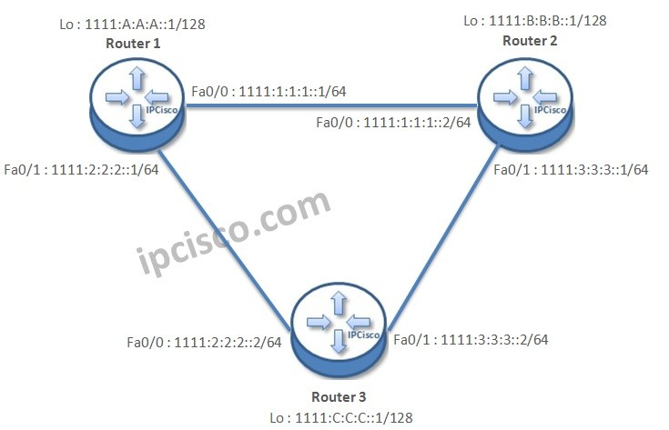

Here, for **Cisco RIPng configuration** there are two steps. These steps are:

1) Enabling CEF, IPv6 and RIPng globally,  
2) Enabling RIPng for the specific interface.

You can also check [**IPv6 Questions**](https://ipcisco.com/ipv6-quizes/) Page.

## Enabling CEF, IPv6 and RIPnG on Routers

Firstly we will enable CEF with “**ip cef**” command and again we will enable IPv6 routing with “**ipv6 unicast-routing**” command. After this we need to create RIPng with a name by “**ipv6 router rip ripname**” command.

Router1# **configure terminal**

Router1(config)# **ip cef**

Router1(config)# **ipv6 unicast-routing**

Router1(config)# **ipv6 router rip CompanyNetworkRIP**

|  |
| --- |
|  |

Router2# **configure terminal**

Router2(config)# **ip cef**

Router2(config)# **ipv6 unicast-routing**

Router2(config)# **ipv6 router rip CompanyNetworkRIP**

|  |
| --- |
|  |

Router3# **configure terminal**

Router3(config)# **ip cef**

Router3(config)# **ipv6 unicast-routing**

Router3(config)# **ipv6 router rip CompanyNetworkRIP**

|  |
| --- |
|  |

You can also learn [**How to Configure RIPng on Huawei Routers**](https://ipcisco.com/lesson/ripng-configuration-on-huawei-hcna/)

## Enabling Interfaces for RIPnG on Routers

After these, the second step is enabling the interfaces for RIPng. In RIPv2, networks are become RIP available via network command. But in RIPng, the configuration is done via interfaces not networks.

### **Router 1 RIPng Configuration**

Router1(config)# **interface Loopback0**

Router1(config-if)# **no ip address**

Router1(config-if)# **ipv6 enable**

Router1(config-if)# **ipv6 address 1111:A:A:A::1/128**

Router1(config-if)# **ipv6 rip CompanyNetworkRIP enable**

Router1(config-if)# **exit**

|  |
| --- |
|  |

Router1(config)# **interface FastEthernet0/0**

Router1(config-if)# **no ip address**

Router1(config-if)# **duplex auto**

Router1(config-if)# **speed auto**

Router1(config-if)# **ipv6 enable**

Router1(config-if)# **ipv6 address 1111:1:1:1::1/64**

Router1(config-if)# **ipv6 rip CompanyNetworkRIP enable**

|  |
| --- |
|  |

Router1(config)# **interface FastEthernet0/1**

Router1(config-if)# **no ip address**

Router1(config-if)# **duplex auto**

Router1(config-if)# **speed auto**

Router1(config-if)# **ipv6 enable**

Router1(config-if)# **ipv6 address 1111:2:2:2::1/64**

Router1(config-if)# **ipv6 rip CompanyNetworkRIP enable**

Cisco IOS

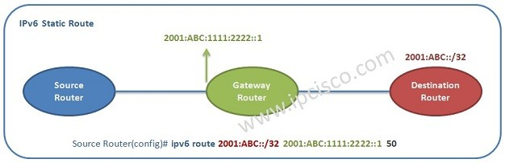

Table of Contents

[](https://ipcisco.com/lesson/ipv6-static-and-default-route-configuration-on-cisco-ios/)

* [IPv6 Static Route Configuration on Cisco IOS](https://ipcisco.com/lesson/ipv6-static-and-default-route-configuration-on-cisco-ios/#IPv6_Static_Route_Configuration_on_Cisco_IOS)
* [IPv6 Default Route Configuration on Cisco IOS](https://ipcisco.com/lesson/ipv6-static-and-default-route-configuration-on-cisco-ios/#IPv6_Default_Route_Configuration_on_Cisco_IOS)

IPv6 Static Route Configuration on Cisco IOS

As you know, **Static Route** is the route that you manually define on a router.This is done when we do not want to use Routing Protocols for small part of a network. Or, in large networks some small amout of routing is done via static routing. For IPv6, we use **IPv6 Static Routes**.

To define a **IPv6 Static Route**, we will firstly write the prefix OR the network we will reach and then, the next hop to reach that network.

If you would like to test your NRS I Knowledge, you can do this on [**Nokia NRS I Question Page**](https://ipcisco.com/nrs-1-quizes/).

As IPv4 static routes, we can also use static routes for IPv6 addresses. Here, the only difference is using IPv6 addresses. In other words, the destintion and the next hop addresses are IPv6 addresses in IPv6 static routing configuration.

For example, let’s do an IPv6 static route configuration example with **2001:ABC::/32** network and **2001:ABC:1111:2222::**1 next hop adres. To do this configuration, we can use the below command:

Router(config)#**ipv6 route 2001:ABC::/32 2001:ABC:1111:2222::1**

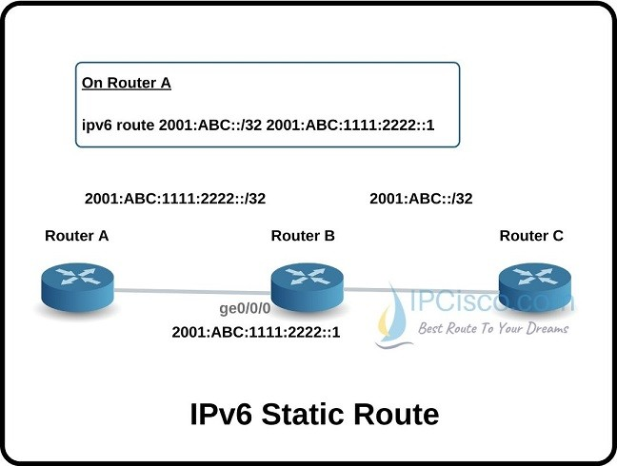

IPv6 Default Route Configuration on Cisco IOS

The **Default Route** is a type of **static routing**. They are used whenever the destination of the packet is not reside in the routing table of the router. So, the traffic is sent to the destination mentined in default route if there is no route information in the router about this destination.

Default rotues for IPv4 is configured with IPv4 addresses. **IPv6 Default routes** are configured with IPv6 addresses. For this, in IPv4, we **use 0.0.0.0/ source default route** and in IPv6, we use **::/0**.

For IPv6 default route configuration, after “**ipv6 route**” command, we will use IPv6 default source IP address **(::/0**). And then, we will use next hop IPv6 address.

Below, you can find a default IPv6 route example with the next hop **2001:ABC:33:44::1**.

Router(config)#**ipv6 route ::/0 2001:ABC:33:44::1**

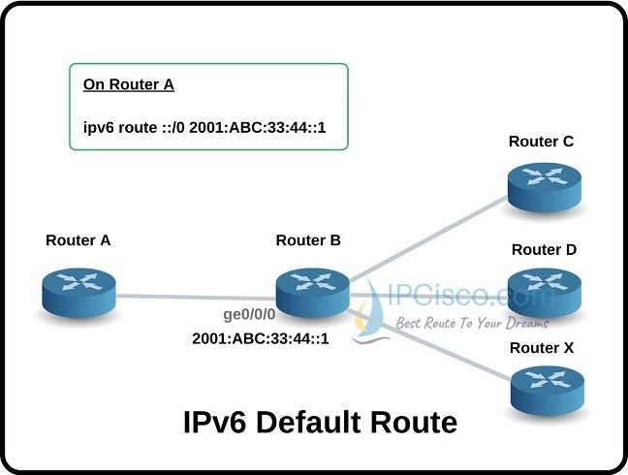

With this **IPv6 Default Route Configuration**, if the destination address of the packet is not known, the traffic is sent to the **2001:ABC:33:44::1** interface by default.

# Basic Multipoint Frame Relay Configuration

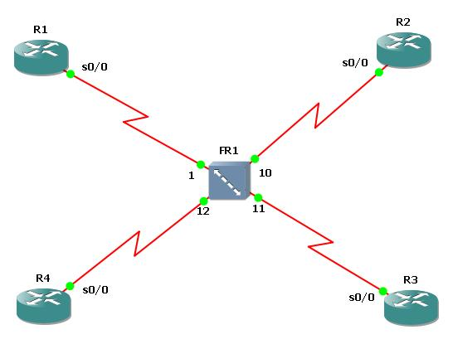

# Basic Multipoint Frame RelayConfiguration on Cisco

Here, in multipoint Frame-Relay configuration, we will use the same Cisco 3600 series routers and a frame relay switch. But here, our configuration will not be point-to-point only. Routers will be connecting to the routers as multipoint.

We will start with Frame-Relay Switch again.Create a Frame-Relay Switch and right click the Frame-Relay Switch. Adjuct the DLCI – port mapping like below:

**1:102 10:201**  
**1:103 11:301**  
**1:104 12:401**

After mapping, connect the routers to the Frame-Relay Switch port mentioned in the mapping via serial connection. **( R1 to port 1, R2 to port 10, R3 to port 11, R4 to port 12)**

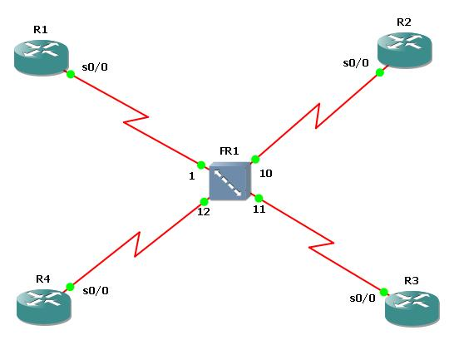

It is time to configure our routers. The Hub Router is R1 again. Make the below configurations on all routers.

**R1 Configuration**

R1(config)# **no logging console**

R1 (config)# **int s 0/0**

R1 (config-if)# **no shut**

R1 (config-if)# **encapsulation frame-relay**

R1 (config-if)# **ip address 192.168.10.1 255.255.255.0**

R1 (config-if)# **frame-relay map ip 192.168.10.2 102 broadcast**

R1 (config-if)# **frame-relay map ip 192.168.10.3 103 broadcast**

R1 (config-if)# **frame-relay map ip 192.168.10.4 104 broadcast**

R1 (config-if)# **end**

R1 # **write**

|  |
| --- |
|  |

**R2 Configuration**

R2 (config)# **no logging console**

R2 (config)# **int s 0/0**

R2 (config-if)# **no shut**

R2 (config-if)# **encapsulation frame-relay**

R2 (config-if)# **ip address 192.168.10.2 255.255.255.0**

R2 (config-if)# **frame-relay map ip 192.168.10.1 201 broadcast**

R2 (config-if)# **frame-relay map ip 192.168.10.3 201 broadcast**

R2 (config-if)# **frame-relay map ip 192.168.10.4 201 broadcast**

R2 (config-if)# **end**

R2 # **write**

|  |
| --- |
|  |

**R3 Configuration**

# Basic Frame Relay Point-to-Point Configuration

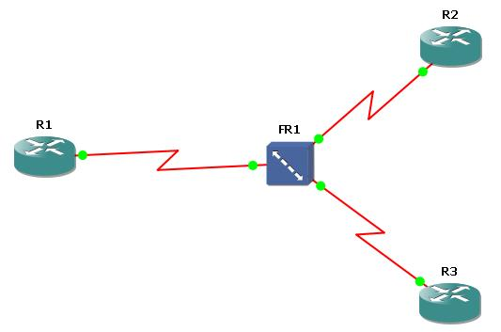

# Basic Frame Relay Point-to-Point Configuration on Cisco

AS you know Frame-Relay is a **well-known WAN technology** that generally used for backbone routers. To understand the basic configuration of Frame-Relay, there is a configuration below with three Cisco 3600 Series Router and one Frame-Relay Switch.

First of all, we will start with Frame-Relay Switch. On GNS3 create a Frame-Relay Switch and right click the Frame-Relay Switch. Configure the DLCI – port mapping like below:

**1:101 10:202**

**1:102 11:203**

After mapping, connect the routers to the Frame-Relay Switch port mentioned in the mapping via serial connection. **( R1 to port 1, R2 to port 10, R3 to port 11)**

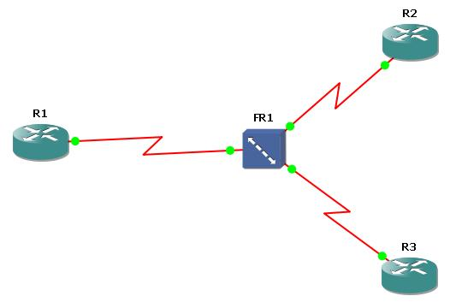

It is time to configure our routers. Starting with the R1 make the below configuration. Here, the Hub Router is R1.

**R1 Configuration**

R1(config)# **no logging console**

R1 (config)# **int s 0/0**

R1 (config-if)# **no shut**

R1 (config-if)# **encapsulation frame-relay**

R1 (config-if)# **interface s0/0.1 point-to-point**

R1 (config-subif)# **ip address 192.168.100.1 255.255.255.252**

R1 (config-subif)# **frame-relay interface-dlci 101**

R1 (config-fr-dlci)# **exit**

R1 (config-subif)# **interface s0/0.2 point-to-point**

R1 (config-subif)# **ip address 192.168.100.5 255.255.255.252**

R1 (config-subif)# **frame-relay interface-dlci 102**

R1 (config-fr-dlci)# **exit**

R1 (config-subif)# **write**

|  |
| --- |
|  |

Now, configure the R2 for Frame-Relay. Here you can get help from **“show frame-relay pvc”** command.

**R2 Configuration**

R2 (config)# **no logging console**

R2 (config)# **int s 0/0**

R2 (config-if)# **no shut**

R2 (config-if)# **encapsulation frame-relay**

R2 (config-if)# **interface serial 0/0.1 point-to-point**

R2 (config-subif)# **ip address 192.168.100.2 255.255.255.252**

|  |
| --- |
|  |

# Basic Frame-Relay Configuration with both Inverse-ARP and Frame-Relay Map Command

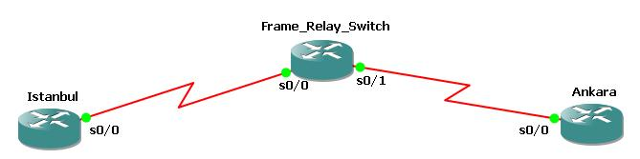

[/wcm\_restrict]

# Basic Frame-Relay Configuration with Both Inverse-ARP and Frame-Relay Map Command

Here, we will talk about two options for configuring Frame-Relay Maps. One is Inverse-ARP and the other is with “frame-relay map” command. To show this in a basic topology, we will use the below topology configured with three Cisco 3600 series routers.

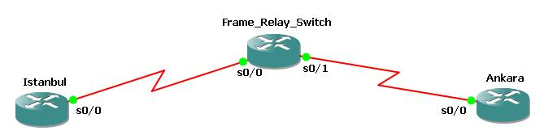

Firstly, we will start to do the configuration for Inverse-ARP way.The configurations are below:

**Istanbul Router Configuration**

Istanbul (config) # **interface serial 0/0**

Istanbul (config-if) # **ip address 210.0.0.1 255.255.255.0**

Istanbul (config-if) # **encapsulation frame-relay**

Istanbul (config-if) # **frame-relay interface-dlci 100**

Istanbul (config-if) # **no shutdown**

Istanbul (config-if) # **end**

Istanbul # **write**

|  |
| --- |
|  |

**Note 1 :** In Cisco routers you must enter “frame-relay switching” command to configure the router as a frame-relay switch.

**Note 2 :** If there is another router aside from Cisco router, then you must use “encapsulation frame-relay ietf” command.

**Frame-Relay Switch Configuration**

FR\_Switch (config) # **interface serial 0/0**

FR\_Switch (config-if) # **no ip address**

FR\_Switch (config-if) # **encapsulation frame-relay**

FR\_Switch (config-if) # **clock rate 64000**

FR\_Switch (config-if) # **frame-relay intf-type dce**

FR\_Switch (config-if) # **frame-relay route 100 interface serial 0/1 300**

FR\_Switch (config-if) # **no shutdown**

FR\_Switch (config-if) # **exit**

FR\_Switch (config) # **interface serial 0/1**

FR\_Switch (config-if) # **no ip address**

FR\_Switch (config-if) # **encapsulation frame-relay**

FR\_Switch (config-if) # **clock rate 64000**

FR\_Switch (config-if) # **frame-relay intf-type dce**

FR\_Switch (config-if) # **frame-relay route 300 interface serial 0/0 100**

FR\_Switch (config-if) # **no shutdown**

FR\_Switch (config-if) # **end**

FR\_Switch # **write**

|  |
| --- |
|  |

**Ankara Router Configuration**

Ankara (config) # **interface serial 0/0**

Ankara (config-if) # **ip address 210.0.0.2 255.255.255.0**

Ankara (config-if) # **encapsulation frame-relay**

Ankara (config-if) # **frame-relay interface-dlci 300**

Ankara (config-if) # **no shutdown**

Ankara (config-if) # **end**

Ankara # **write**

# PPP Configuration on Cisco

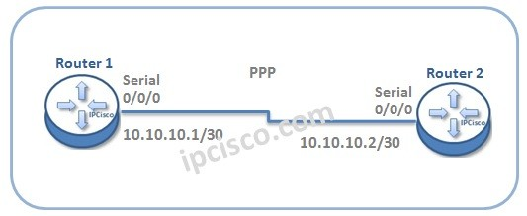

Table of Contents

[](https://ipcisco.com/lesson/ppp-configuration-on-cisco/)

* [PPP Configuration on Cisco Routers](https://ipcisco.com/lesson/ppp-configuration-on-cisco/#PPP_Configuration_on_Cisco_Routers)
  + [Enabling PPP](https://ipcisco.com/lesson/ppp-configuration-on-cisco/#Enabling_PPP)

## PPP Configuration on Cisco Routers

In this lesson, we will talk about **PPP Configuration** (Point-to-Point Protocol Configuration) on Cisco Routers. We will learn configuration commands for this general standard wan connection.

In our **PPP Configuration** example, we will use the below basic topology:



Now, do not waste time and let’s start to **configure PPP** for this topology.

### **Enabling PPP**

To configure **Point-to-Point Protocol**, firstly we will **enable PPP**and after that, we will configure the interface **ip addresses**.

Router1>**enable**

Router1# **configure terminal**

Router1(config) # **interface Serial 0/0/0**

Router1(config-if) # **encapsulation ppp**

Router1(config-if) # **ip address 10.10.10.1 255.255.255.252**

Router1(config-if) # **exit**

|  |
| --- |
|  |

Now, let’s configure Router 2 for PPP like above. Here, only the ip address of the interface will be changed. All the other configurations steps will be same.

Router2>**enable**

Router2# **configure terminal**

Router2(config) # **interface Serial 0/0/0**

Router2(config-if) # **encapsulation ppp**

Router2(config-if) # **ip address 10.10.10.2 255.255.255.252**

Router2(config-if) # **exit**

|  |
| --- |
|  |

# HDLC Configuration on Cisco

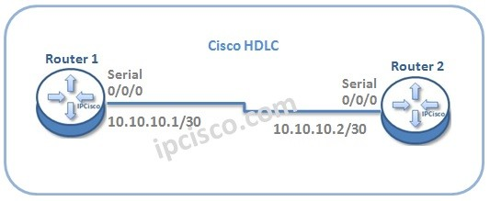

In this lesson, we will talk about **HDLC configuration** on **Cisco** Routers. Cisco HDLC has a different proprietary field in the data field of the protocol.

For our **Cisco HDLC Configuration** example, we will use the below basic topology:



Let’s start to configure Cisco HDLC for this topology.

### **Enabling Cisco HDLC**

To configure Cisco HDLC, firstly we will enable HDLC and after that, we will configure interface ip addresses.

Router1>**enable**

Router1# **configure terminal**

Router1(config) # **interface Serial 0/0/0**

Router1(config-if) # **encapsulation hdlc**

Router1(config-if) # **ip address 10.10.10.1 255.255.255.252**

Router1(config-if) # **exit**

|  |
| --- |
|  |

Now, let’s configure Router 2 for HDLC like above.